Meeting the right needs first…
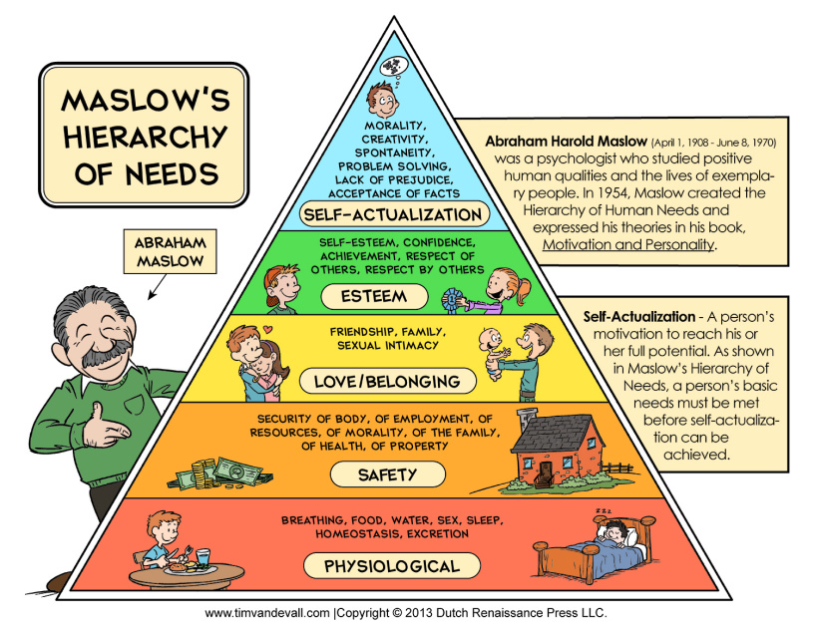
By a hierarchy of needs, Maslow means that we cannot focus on any level of need until the needs in the levels below have been met.
For example, if am starving and have no access to food and water, I must deal with that before I will be worried about having a safe place to stay.
We all meet these needs in different ways, for example:
- “Home” means different things for different people
- We all find love and belonging in different ways.
Some people who have mental health needs may feel unsafe even if we think they have a stable home and secured income. They may not feel ready to think about relationships or self-esteem building even if we think they are ready.
It may be helpful to use the next page to think about how this hierarchy relates to the person you care for.
What I currently do to support my wellbeing… | What I will start doing to improve this area for me? | When I make this positive change I will feel…
Maslow’s Hierarchy of Needs

